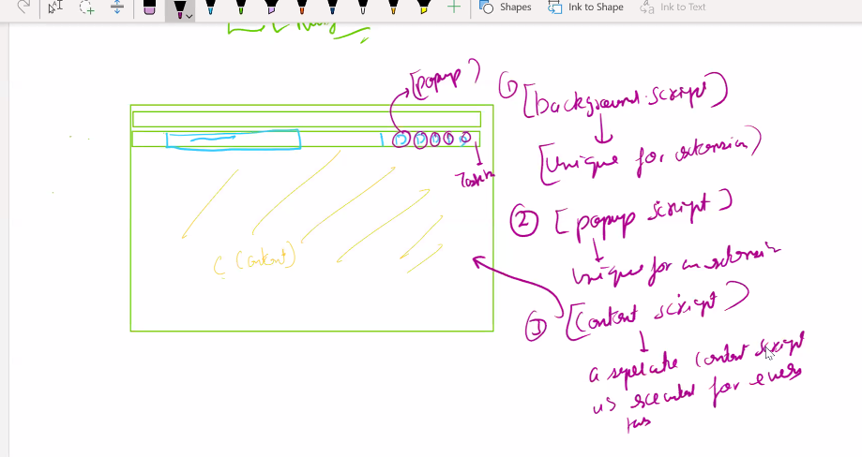

Manifest.json ek file hoti hai chrome ke andar jo chrome ko batata haii which extension is defined how ?

2-some of the apis required permission like you want to use some memory

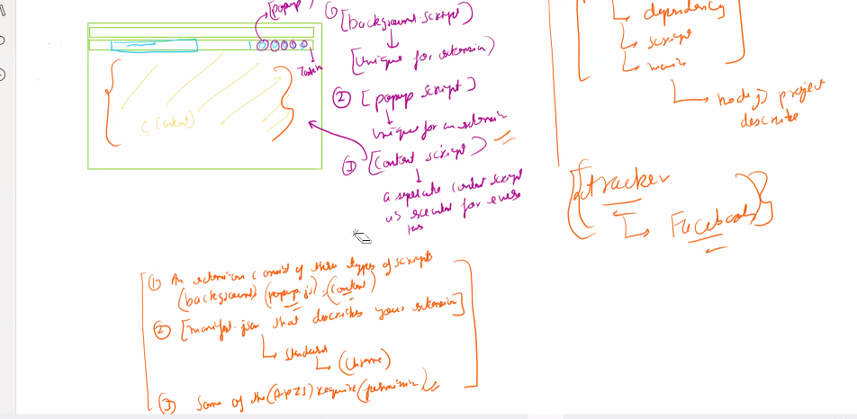

HOW TO SET IMAGES IN DOM CONTENT

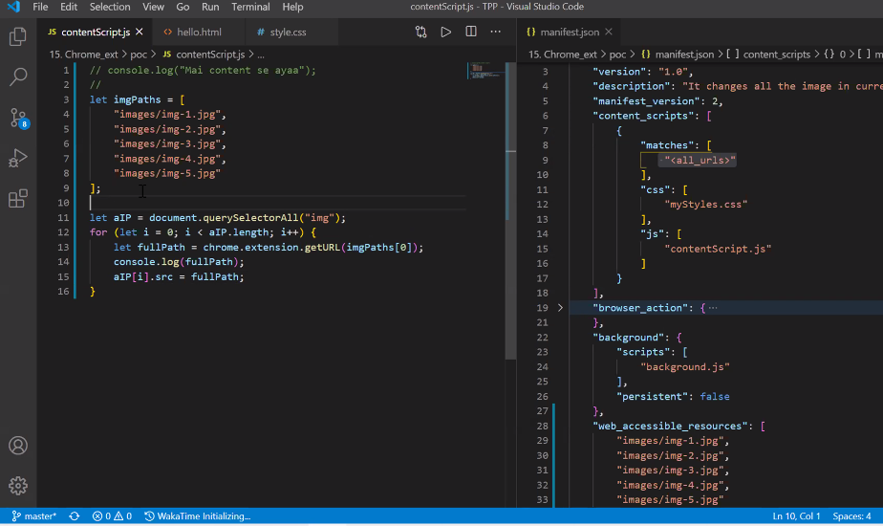

REMEMBER THAT YOU CAN NOT DIRECTLY SET IMAGE YOU HAVE TO USE CHROME API TO GENERATE A UNIQUE LINK FOR IMAGE SO THAT CAN IT CAN BE USED

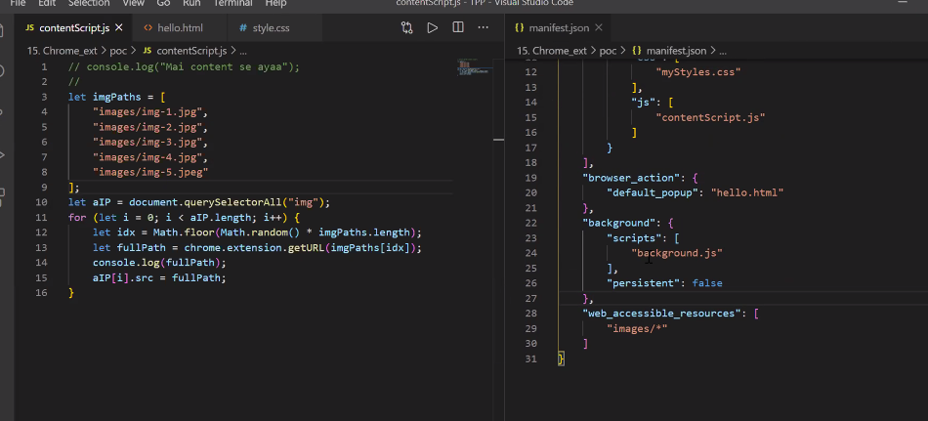

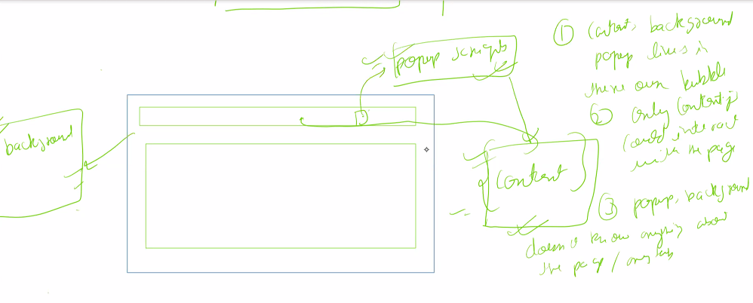

Event listeners communication betwewn chrome files

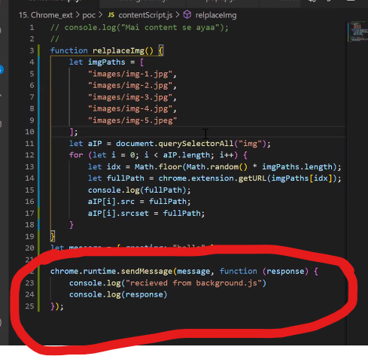

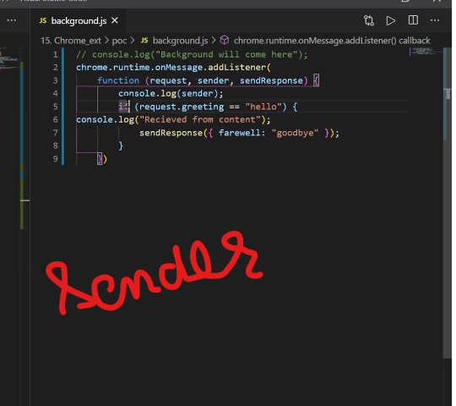

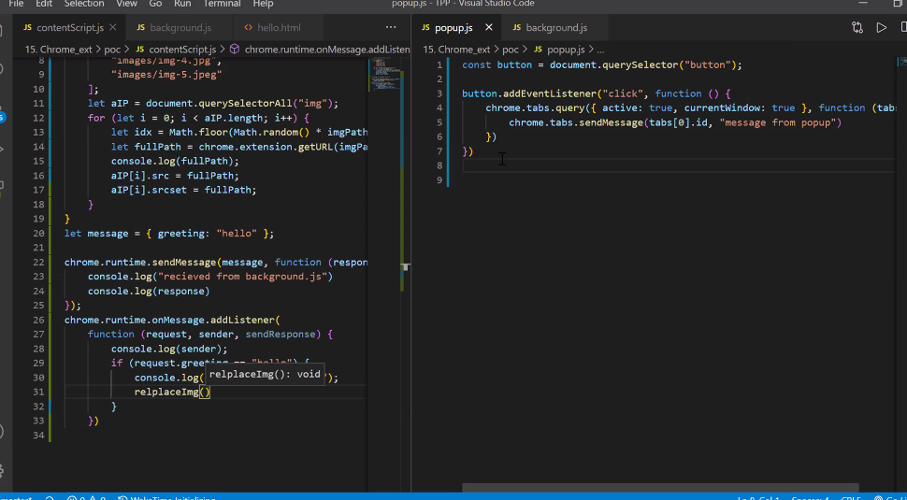

HOW TO SET UP COMMUNICATION

STEP-1 SENDEER(HERE CONTENT SCRIPT IS SENDER)

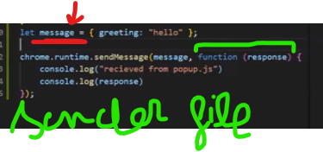

SOCIAL MEDIA BLOCKER

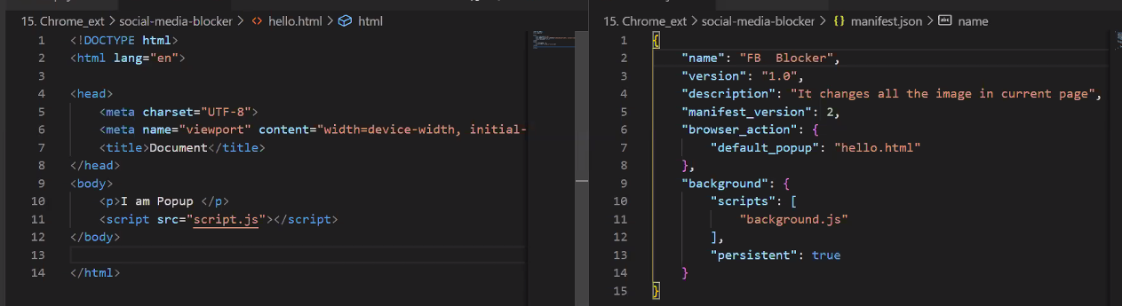

LINKED LIST

